# How to create button and update the count of clicks

## Table of Content

In this article you can learn how to:

* Create a simple button.
* Attach click event on it.
* Update the count of clicks.

## Create the html page

To create this type of button you need to create an html page. It’s simple – you can do it with every text editor, just save it with html extension.

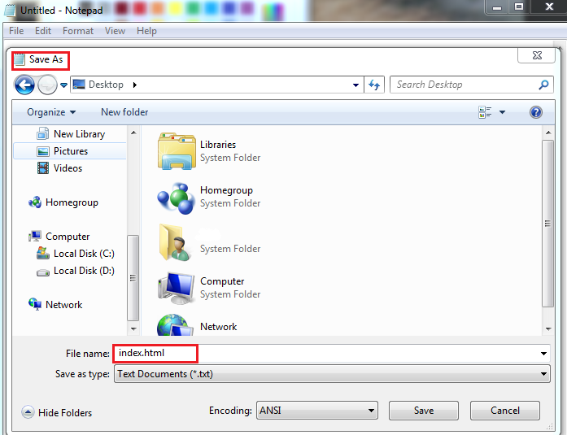

Recommendations for text editors:

* [Notepad++](https://notepad-plus-plus.org/)
* [Sublime Text](http://www.sublimetext.com/)
* [WebStorm](https://www.jetbrains.com/webstorm/)
* [Visual Studio](https://www.visualstudio.com/)

The last two editors are suitable for bigger applications.

Now you can begin writing the code. [Here](http://www.w3schools.com/html/html5_intro.asp) you can see the main skeleton of an html page. The content to be seen is located in the *body* tag.

To create a button you can either choose [*button*](http://www.w3schools.com/tags/tag_button.asp)or[*input*](http://www.w3schools.com/tags/att_input_type.asp) (it must be with type=”button”) tags.

In the example below I’m using *input* with attribute *type* button.

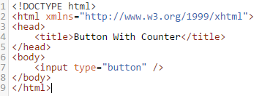

You will need another two important attributes –[*value*](https://msdn.microsoft.com/en-us/library/ms535126(v=vs.85).aspx),[*onclick*](http://www.w3schools.com/tags/ev_onclick.asp)and [*id*](http://www.w3schools.com/tags/att_global_id.asp).

The *onclick* is used to attach a function from the script that will be called after clicking the element.

The *id* is needed to access the element from the script - [example](https://developer.mozilla.org/en-US/docs/Web/API/Document/getElementById).

## Create script

The script can be in separate file – it’s the good practice, but in the example it’s in the html with *script* tag.

You have to create a function with the same name as the value of the *onclick* attribute on the element.

Using function [getElementById](https://developer.mozilla.org/en-US/docs/Web/API/Document/getElementById) you select the element with the given *id*.

The [*value*](https://msdn.microsoft.com/en-us/library/ms535126(v=vs.85).aspx) property gives you the value assigned to *value* attribute of the element.

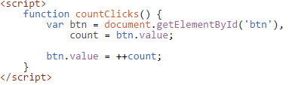

## Create styles

Optionally you can add some style to position the elements and you can add colors.

More information [here](http://www.w3schools.com/cssref/pr_background-color.asp).

## Simple Example

[Test it here.](http://dojo.telerik.com/OdeSu/11)

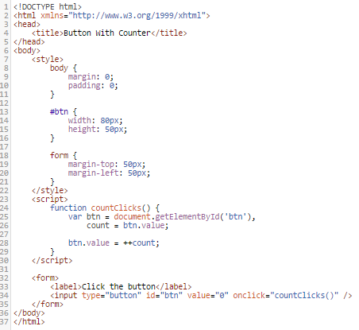

Results:

